Current times

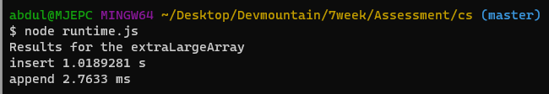

Talking about the insert, it starts off taking less times, but once it gets to the medium array, it starts increasing exponentially in terms of time.

Talking about the append, we start off with it taking more time, then it takes less time, then it takes more time as the array gets larger but not exponentially like the insert.